SET 16
Set 16: Customer Demographics Analysis
1. Aim
To analyze the age and gender distribution of the customers and present their demographic details in an interactive Tableau dashboard.
Code:
# Aim: To visualize the age of each customer using a bar chart.
customers <- data.frame(
Customer_ID = c(1, 2, 3),
Age = c(28, 35, 42)
)
# Install ggplot2 once if needed:
# install.packages("ggplot2")
library(ggplot2)
ggplot(customers, aes(x = factor(Customer_ID), y = Age)) +
geom_col(fill = "steelblue") +
labs(
title = "Age of Each Customer",
x = "Customer ID",
y = "Age (years)"
) +
theme_minimal()

Output:
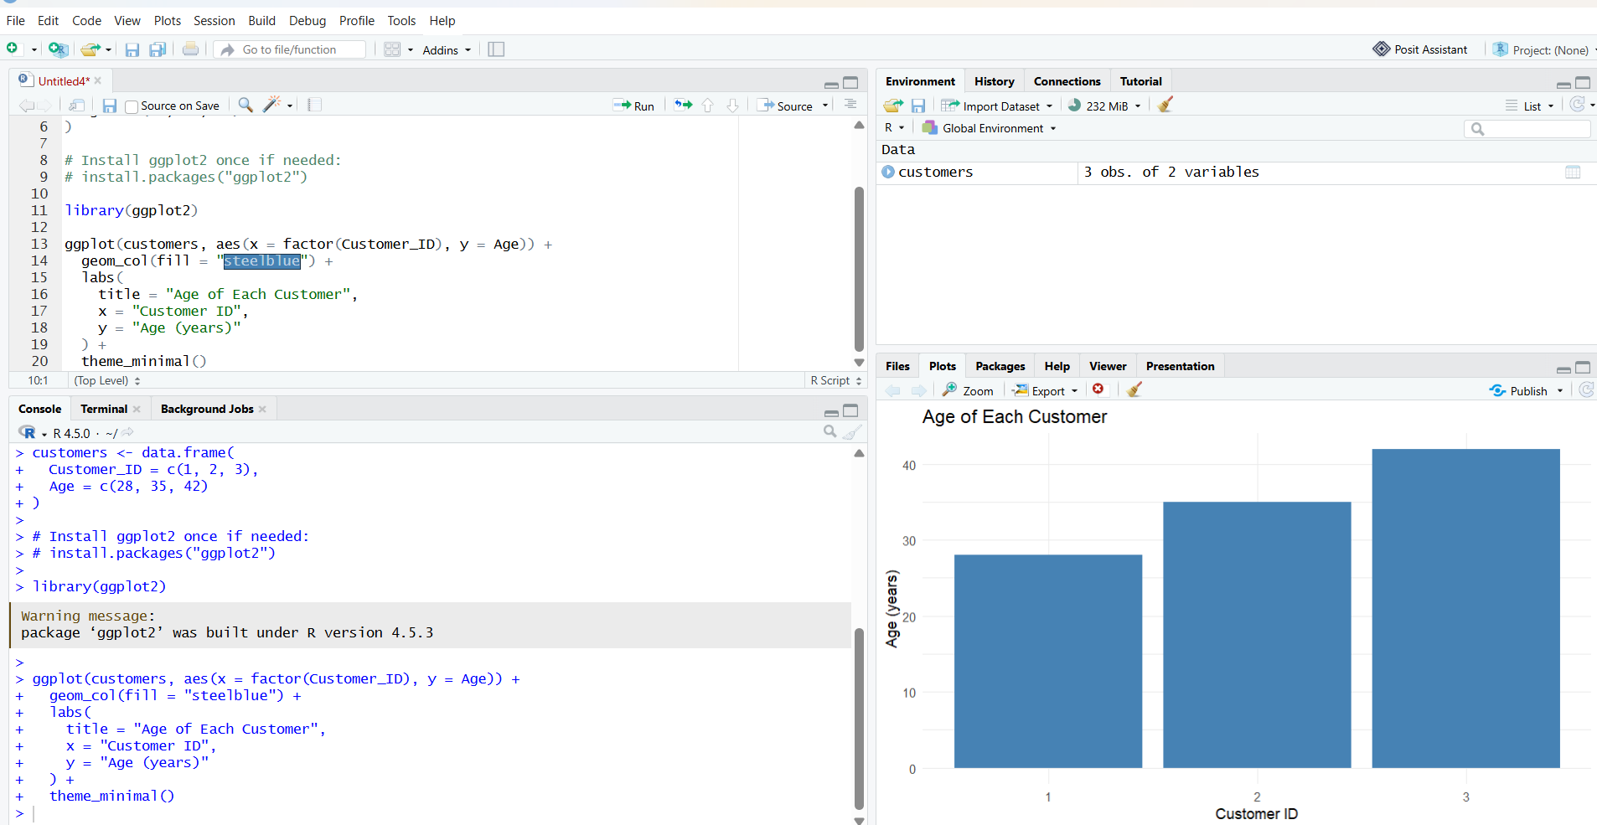
2.
Aim: To show the distribution of customers by gender using a pie chart.
Code:
# Aim: To show the distribution of customers by gender using a pie chart.
customers <- data.frame(
Gender = c("Female", "Male", "Female")
)
# Install ggplot2 once if needed:
# install.packages("ggplot2")
library(ggplot2
gender_counts <- as.data.frame(table(customers$Gender))
names(gender_counts) <- c("Gender", "Count")
ggplot(gender_counts, aes(x = "", y = Count, fill = Gender)) +
geom_col(width = 1) +
coord_polar(theta = "y") +
labs(
title = "Customer Distribution by Gender",
fill = "Gender"
) +
theme_void()
Output:
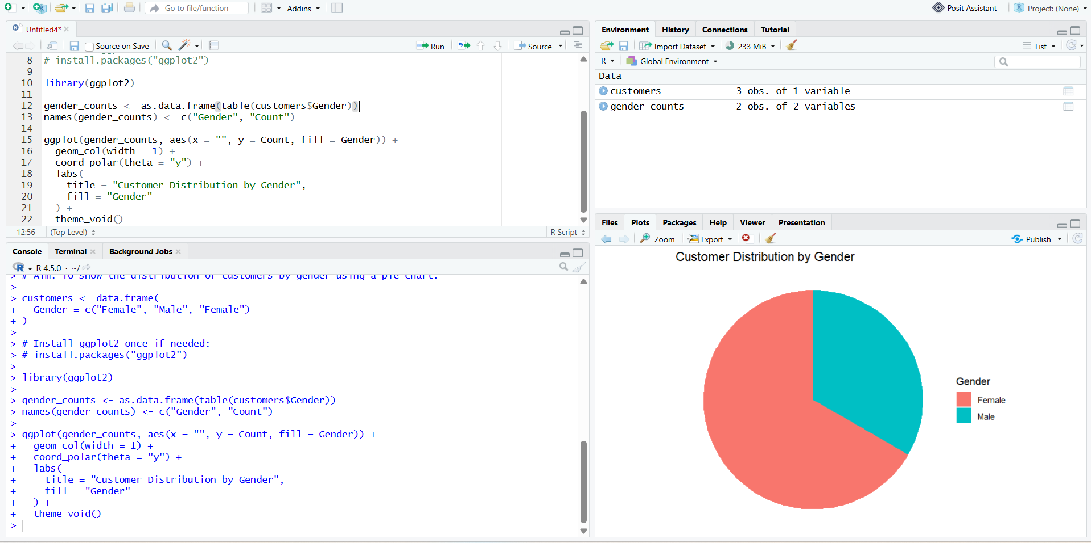
3.Aim: To create a labeled table showing the demographic information for each customer.
Code:
customers <- data.frame(
Customer_ID = c(1, 2, 3),
Age = c(28, 35, 42),
Gender = c("Female", "Male", "Female"),
Income = c(50000, 60000, 75000)
)
# Install knitr once if needed:
# install.packages("knitr")
knitr::kable(
customers,
col.names = c("Customer ID", "Age (years)", "Gender", "Income ($)"),
caption = "Customer Demographic Information"
)
Output:
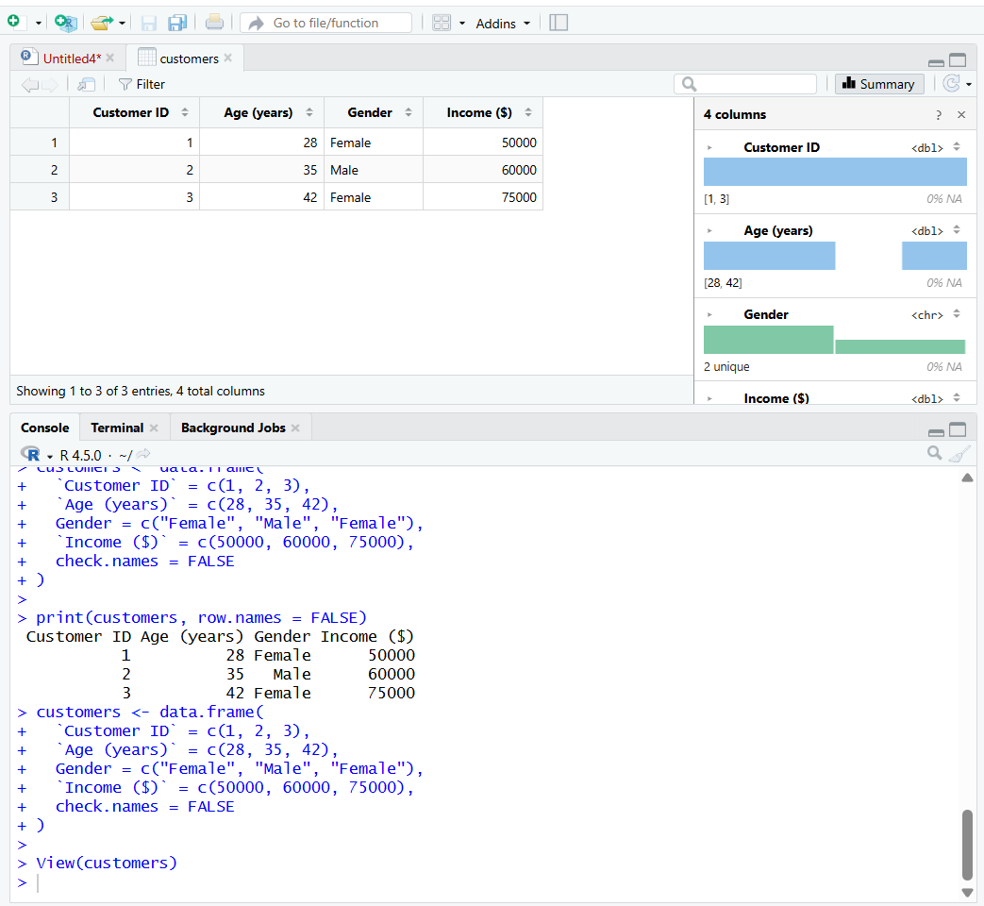
4. Aim: To combine the age bar chart, gender pie chart, and customer demographic table into one interactive dashboard.
